Module 4: Asynchronous & Synchronous Communication Tools
Reflection

Susana Villanueva Eguia Lis

Texas Tech University

Author Note

Susana Villanueva Eguia Lis, Department of Education, Texas Tech University.
Susana Villanueva Eguia Lis, is now at Department of Foreign and Modern Languages and Literatures, Texas Tech University.
Correspondence concerning this article should be addressed to Susana Villanueva, Department of Classical and Modern Languages and Literatures, Texas Tech University, 4202 16th apt 101, Lubbock, Texas, 79416/
Contact: susana.v.berry@gmail.com, susana.eguia@ttu.edu

Module 4: Asynchronous & Synchronous Communication Tools
Reflection

During this module 4 our team tested Synchronous Communication using Skype and Google hangouts. We were able to do a video conference call on both communication tools. Voice and Video streaming was available on both and we had a good connection, which allowed us to see and hear each other in real time.
Since I am interested in learning and teaching foreign languages, I personally think that these two video conferencing tools would be very useful to allow students to talk to people in foreign countries. Students could listen to real native speakers of the language they are studying and could also create an international community in the target language. People who are taking online classes and need to do team projects could also greatly benefit from this synchronous communication tools.
I had used Skype before. I often use it call my family in Mexico but I never use the video. I only use it to call landlines or cellphones. This time it was different because I was able to see video too.
Google hangouts were completely new. I found it a bit challenging to install the software for Google hangouts because I have a mac and it required me to do some extra steps. I was only able to download it and use it successfully because one of my team members knew about it and she explained it to me via Skype while I was working on installing Google hangouts. It was a positive experience because learned from my peer who was very patient and nice to me. I was able to take a couple of screen shots that I will add below:
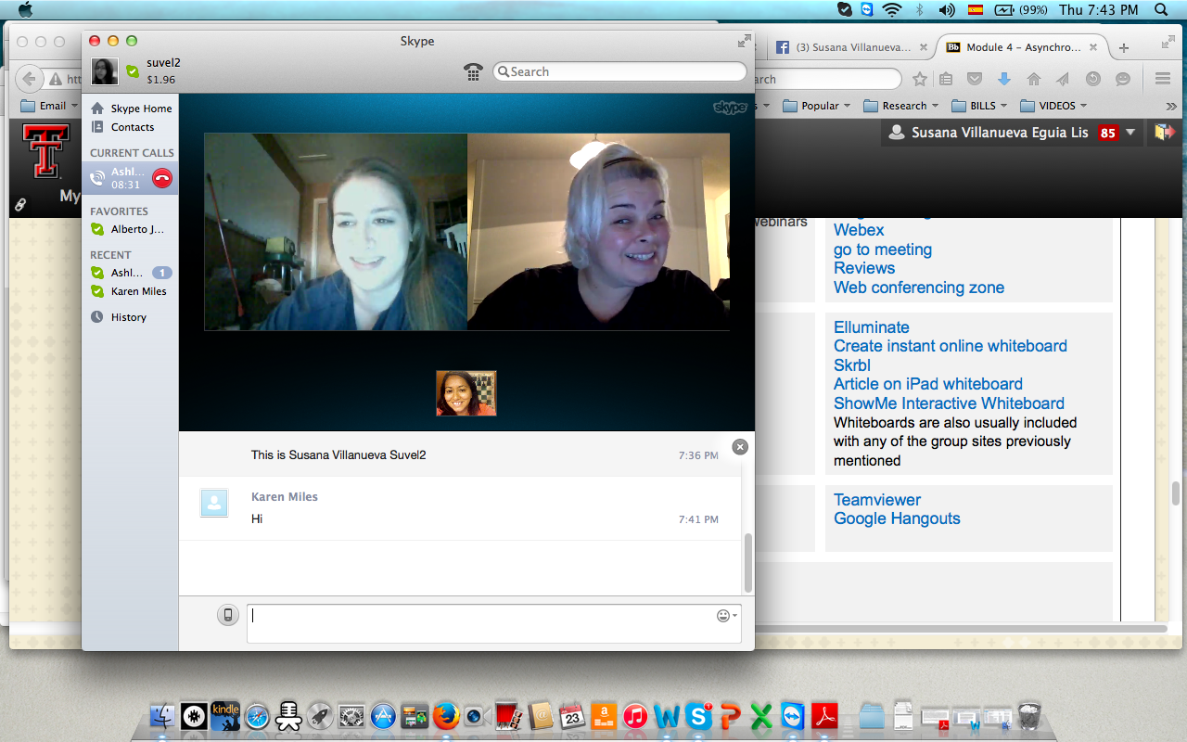
Fig. 1. Using Skype for video conference call with my team.
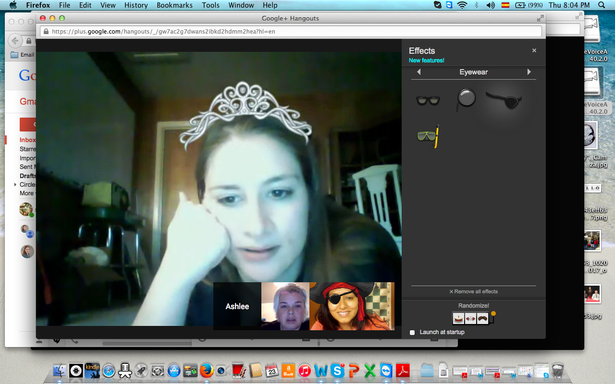
Fig. 2. Using Effects with Google Hangouts

Google hangouts were a fun experience. I added a pirate hat on my head and experimented with mustaches, beards, glasses and different backgrounds. These effects move when you move. A disadvantage of the effects available is that they may be distracting. However, an advantage is that they are icebreakers that help when talking to online classmates who you have never met before.
The asynchronous communication tool that we used was trello, which is a discussion board. We created a board and wrote comments. We also uploaded some screen shots. Here is the actual board we created: https://trello.com/b/3VblBlNA/edit-class
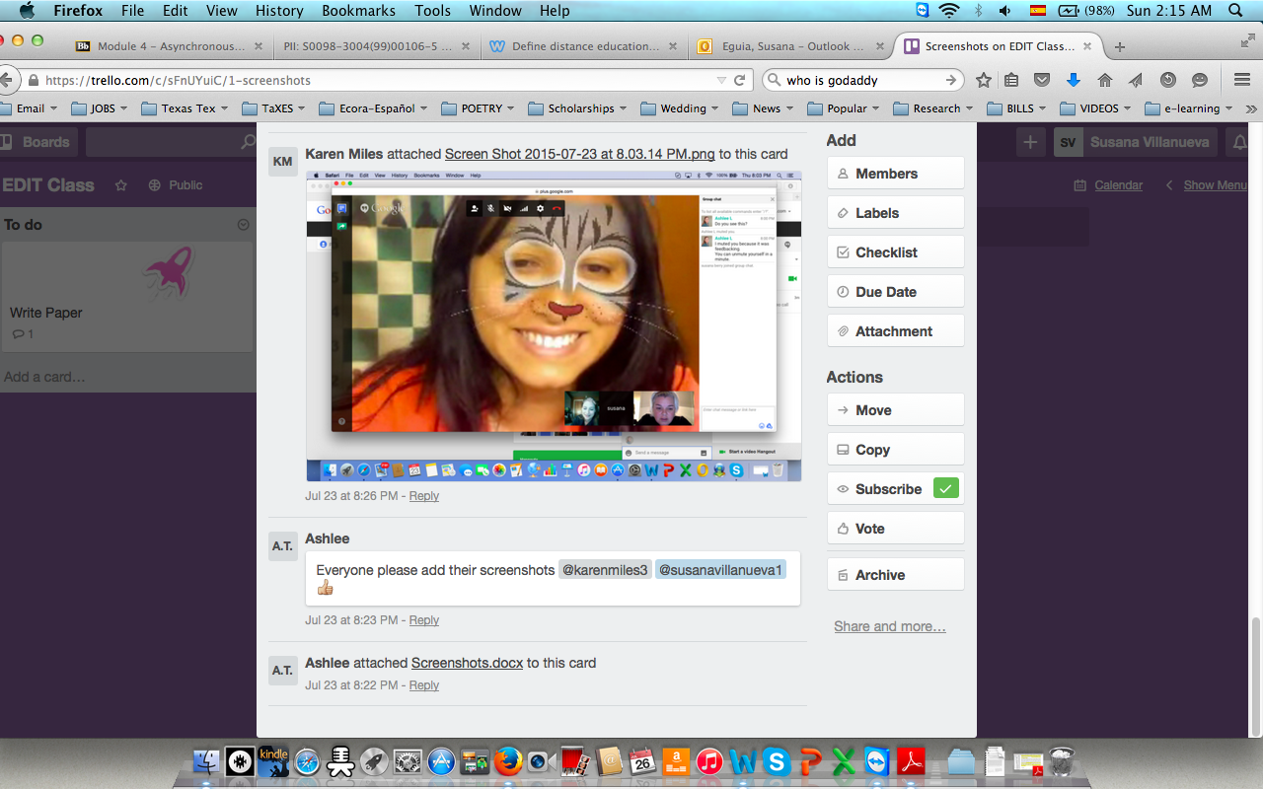
Fig. 3. Screen shot of our Trello.com Board.
I think our team worked really well and it was smooth and easy. Karen was more knowledgeable about the tools than the rest. She practically was like IT support for us. She explained how to download the plug-ins and waited until we were able to meet her inside the communication tools. She also showed us how to share our screen live in order to help another person achieve a task. It was a very positive experience and I would use them both again. Personally I liked the videoconferencing more because it was more personal than the asynchronous board.
The disadvantage of the video call was that we had to exchange several text messages and emails in order to find out a good day and time to meet online. But once it was working it was fun and easy.
My contribution to the team effort I think was that I was able to figure out how to install Google hangouts in my mac first, then I was able to help Ashlee who also has mac.

